C# Tutorial

C# has roots from the C family, and the language is close to other popular languages like [C++](https://www.w3schools.com/cpp/default.asp) and [Java](https://www.w3schools.com/java/default.asp).

The first version was released in year 2002. The latest version, **C# 12**, was released in November 2023.

Why Use C#?

* It is one of the most popular programming languages in the world
* It is easy to learn and simple to use
* It has huge community support
* C# is an object-oriented language which gives a clear structure to programs and allows code to be reused, lowering development costs
* As C# is close to [C](https://www.w3schools.com/c/index.php), [C++](https://www.w3schools.com/cpp/default.asp) and [Java](https://www.w3schools.com/java/default.asp), it makes it easy for programmers to switch to C# or vice versa

C# - Programming points to be noted

A blank line. C# ignores white space. However, multiple lines makes the code more readable.

Every C# statement ends with a semicolon ;  
C# is case-sensitive; "MyClass" and "myclass" have different meaning.

Unlike [Java](https://www.w3schools.com/java/default.asp), the name of the C# file does not have to match the class name, but they often do (for better organization). When saving the file, save it using a proper name and add ".cs" to the end of the filename.

Lets get into C#.

Printing a text:-

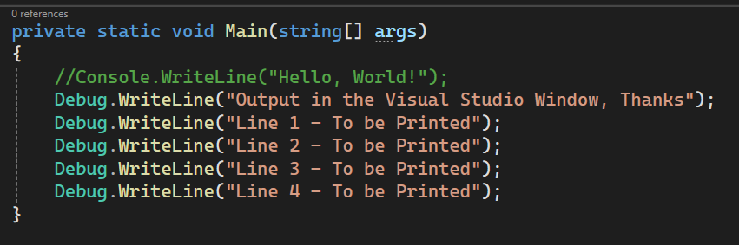

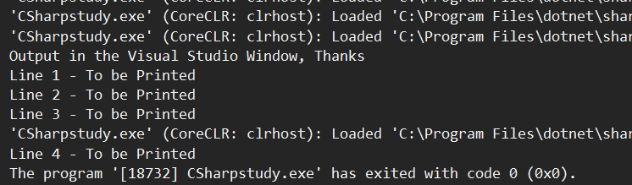

Printing a variable, printing calculations directly in the Writeline statement.

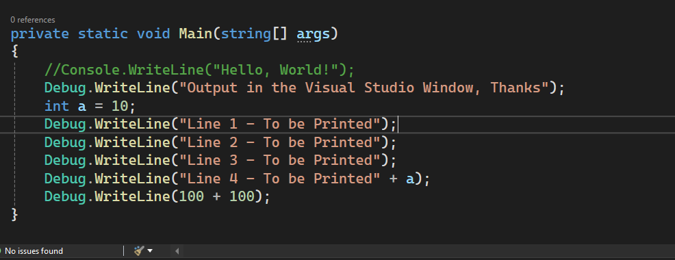

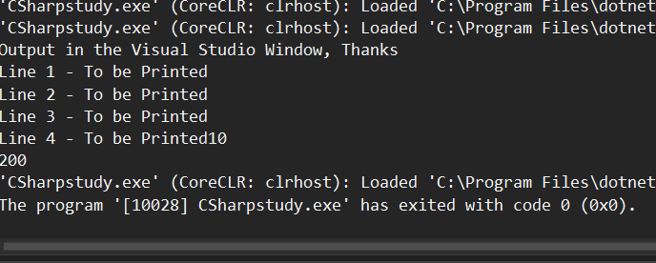

We do have method as Write() and WriteLine(), where as the difference is Write() will print the text in same line and WriteLine() will print in a newline every time.

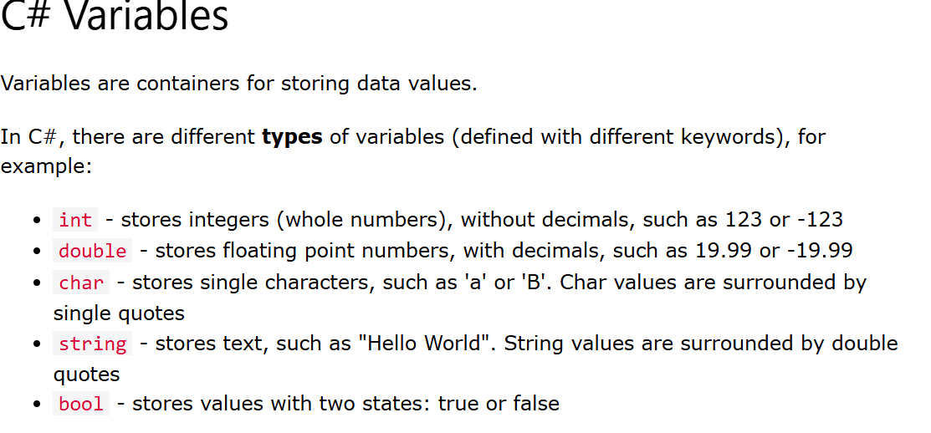

using System.Diagnostics;

class Program

{

private static void Main(string[] args)

{

//Creating variables of Different Data Types in C#

int intgrvalue;

double dblvalue;

char charvalue;

String strvalue;

bool boolvalue;

//Assigning Values

intgrvalue = 123;

dblvalue = 1.23;

charvalue = 'R';

strvalue = "Hello My Dear";

boolvalue = false;

Debug.Write(intgrvalue + ",," + dblvalue + ",," + charvalue + ",," + strvalue + ",," + boolvalue);

}

}

--------------------------------------------,,-----------------------------------------------------

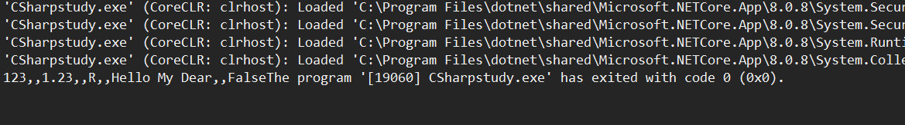

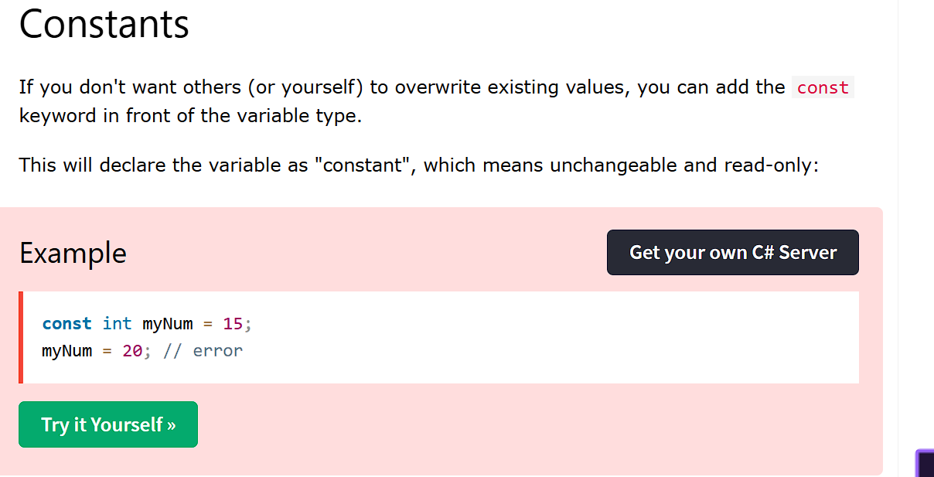

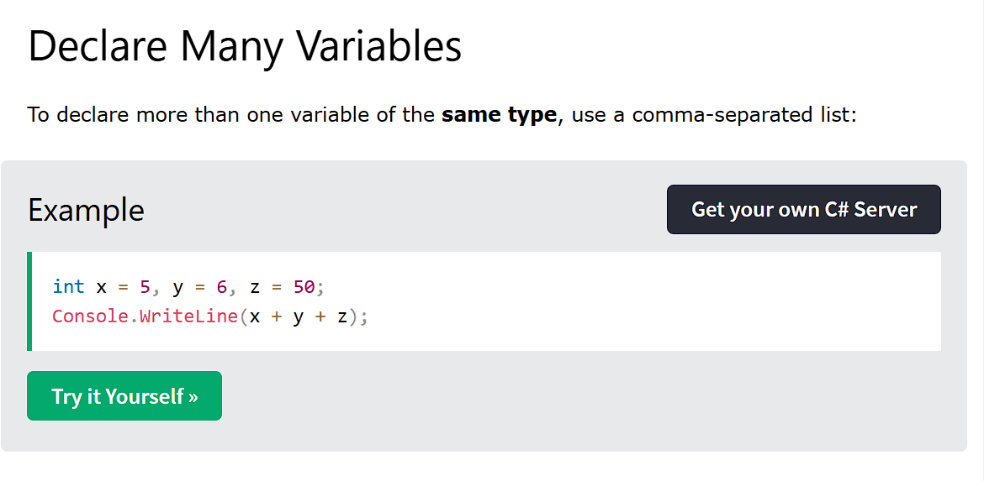

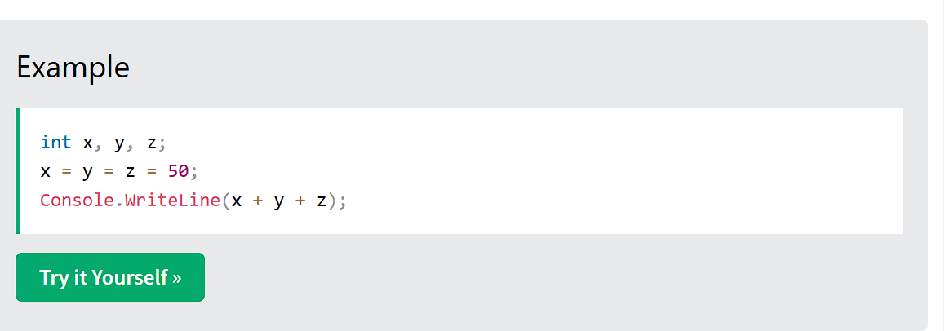

Rules for Creating variables

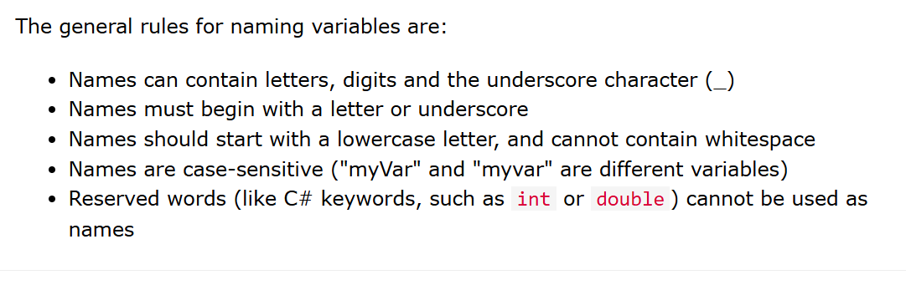

Arithmetic Operators

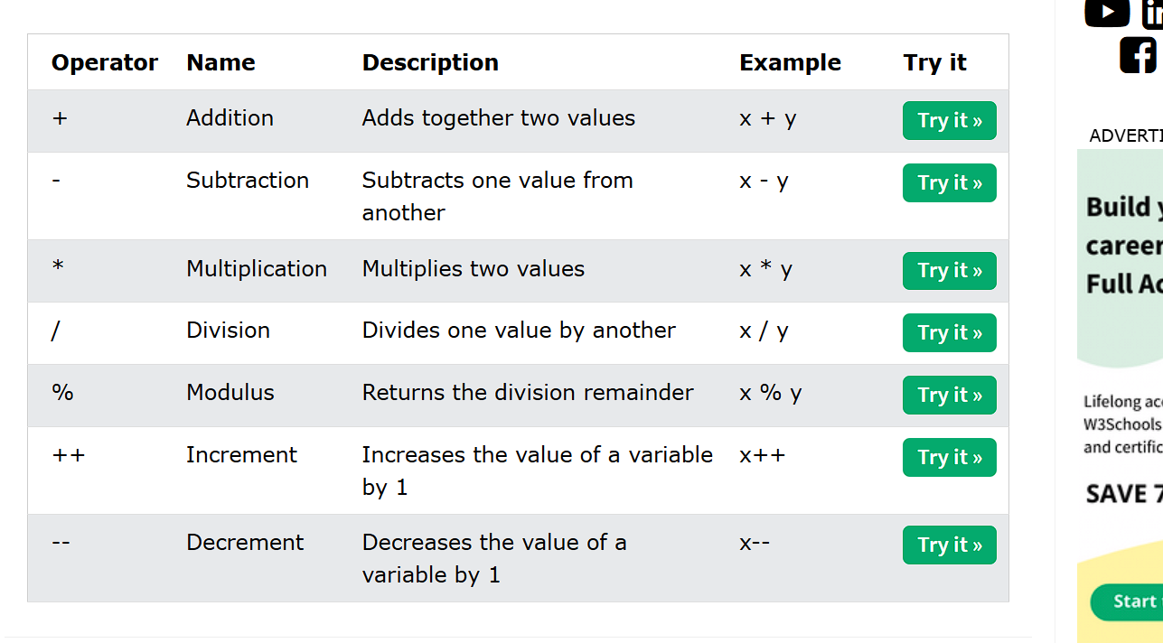

Assignment operators

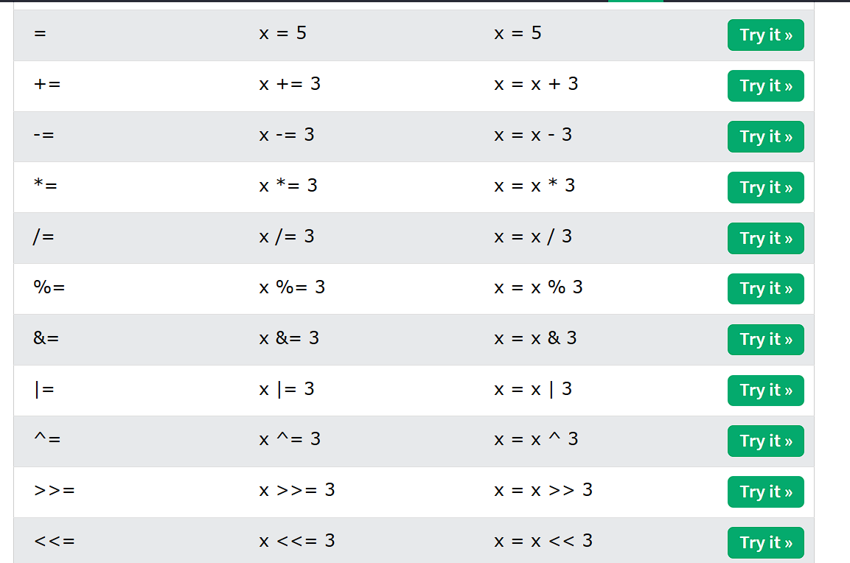

Comparision Operators

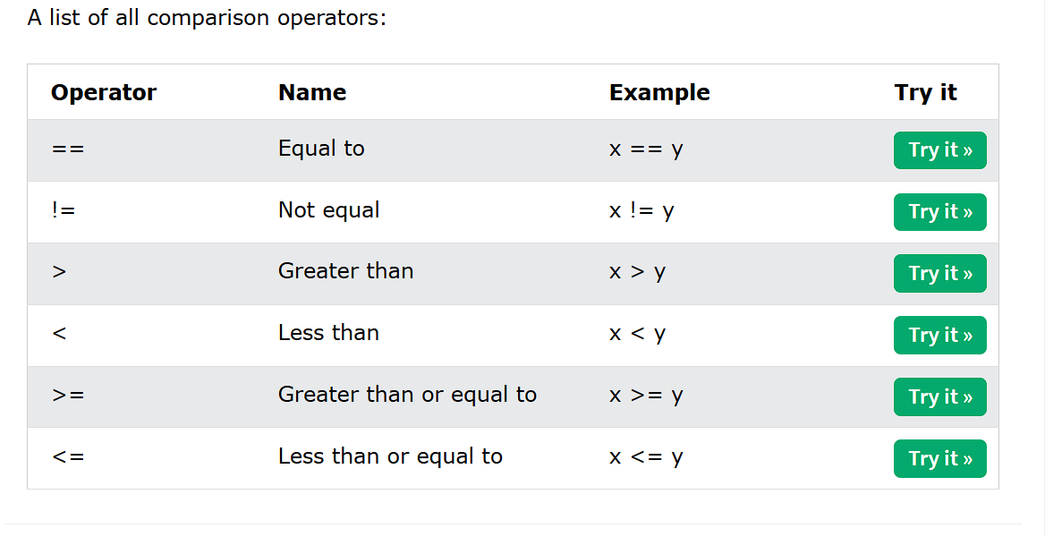

Logical operators

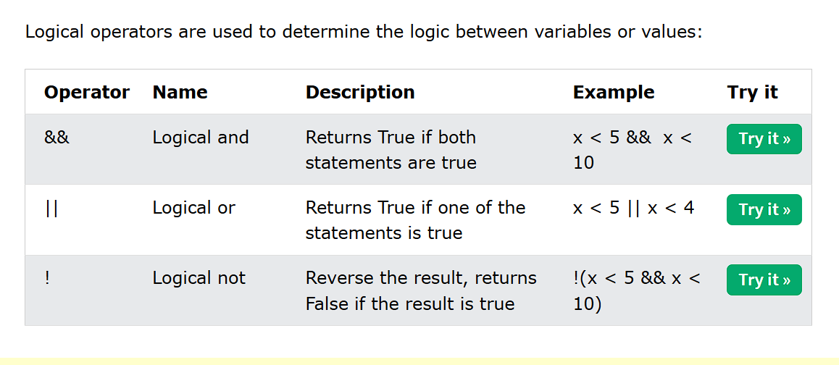

String functions :

**Length**: Returns the number of characters in the string

**Substring**: Extracts a substring from the string

**IndexOf**: Returns the index of the first occurrence of a specified substring

**Contains**: Checks if the string contains a specified substring

**Replace**: Replaces all occurrences of a specified substring with another substring

**ToUpper** and **ToLower**: Converts the string to uppercase or lowercase

**Trim**: Removes all leading and trailing white-space characters from the string

**Split**: Splits the string into an array of substrings based on a specified delimiter

**Join**: Concatenates an array of strings into a single string with a specified separator

**Concat**: Concatenates two or more strings

using System.Diagnostics;

class Program

{

private static void Main(string[] args)

{

//Creating variables of Different Data Types in C#

String validtext = "LoveOfIndia";

Debug.WriteLine("Length of the String: " + validtext.Length);

Debug.WriteLine("Extracts a Substring from the search string : " + validtext.Substring(6));

Debug.WriteLine("Extracts the Index of the Target String or a char : " + validtext.IndexOf("Of"));

Debug.WriteLine("Finds out if the searched text is available in Target String :" + validtext.Contains("Ind"));

validtext = validtext.Replace("o", "#");

Debug.WriteLine("Replaces all occurrences of specified substring in Target String :" + validtext);

Debug.WriteLine("Conversion to Upper Case : " + validtext.ToLower());

Debug.WriteLine("Conversion to Upper Case : " + validtext.ToUpper());

String validtext11 = " LifeOfIndia ";

Debug.WriteLine("Removing empty spaces :" + validtext11);

String concata = "LifeOfIndia";

String concatb = "LiveOfIndia";

String concatc = String.Concat(concata, concatb);

Debug.WriteLine("Concatenating Strings :" + concatc);

}

}

Output of the above program

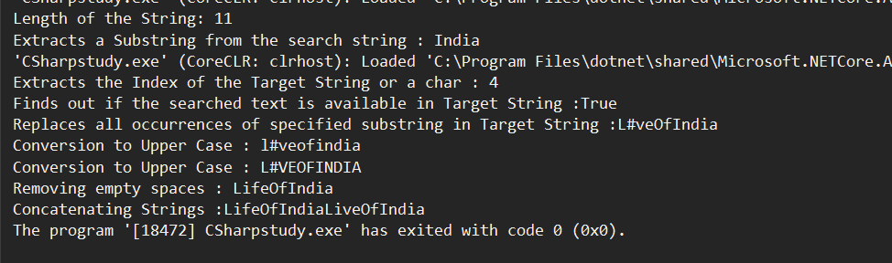

String Interpolation:

Another option of [string concatenation](https://www.w3schools.com/cs/cs_strings_concat.php), is **string interpolation**

using System.Diagnostics;

class Program

{

private static void Main(string[] args)

{

//Creating variables of Different Data Types in C#

String validtext = "LoveOfIndia";

Debug.WriteLine("Length of the String: " + validtext.Length);

Debug.WriteLine("Extracts a Substring from the search string : " + validtext.Substring(6));

Debug.WriteLine("Extracts the Index of the Target String or a char : " + validtext.IndexOf("Of"));

Debug.WriteLine("Finds out if the searched text is available in Target String :" + validtext.Contains("Ind"));

validtext = validtext.Replace("o", "#");

Debug.WriteLine("Replaces all occurrences of specified substring in Target String :" + validtext);

Debug.WriteLine("Conversion to Upper Case : " + validtext.ToLower());

Debug.WriteLine("Conversion to Upper Case : " + validtext.ToUpper());

String validtext11 = " LifeOfIndia ";

Debug.WriteLine("Removing empty spaces :" + validtext11);

String concata = "LifeOfIndia";

String concatb = "LiveOfIndia";

String concatc = String.Concat(concata, concatb);

Debug.WriteLine("Concatenating Strings :" + concatc);

//String Interpolation

String interpola = "12";

String interpolb = "34";

String interpolc = "45";

String combusingInterpol = $"String Interpoling {interpola}, {interpolb}, {interpolc}";

Debug.WriteLine("String combined using Interpolation :" + combusingInterpol);

}

}

Output of the Above program

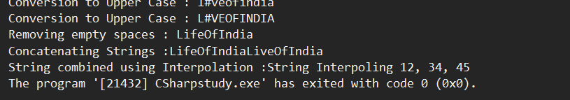

Accessing a string using Index

Accessing a particular character from the target string.

//Access a particular char in a string using Index

String partchar = "ILoveIndia";

Debug.WriteLine("Access Strings :" + partchar[5]);

Output of the above program

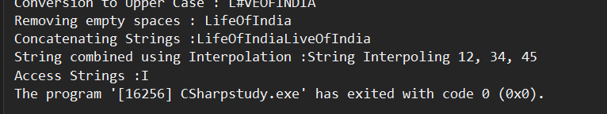

Escape characters in a string

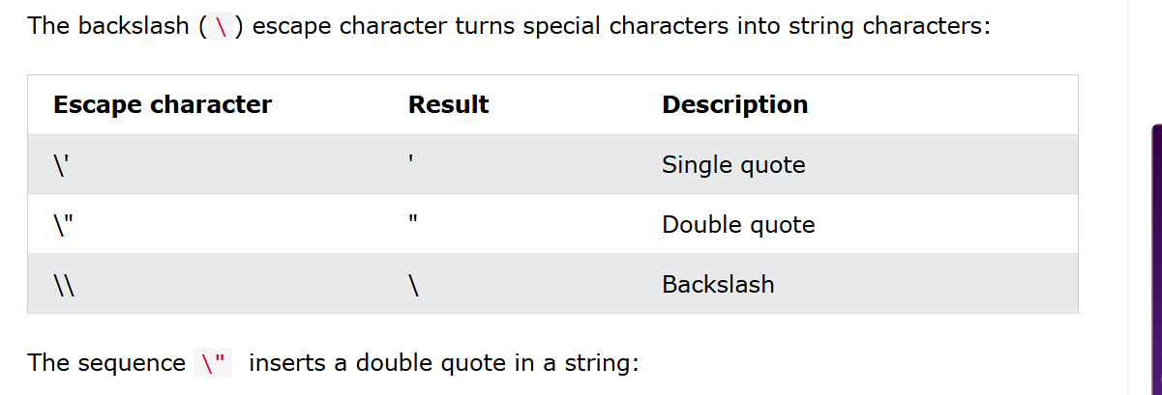

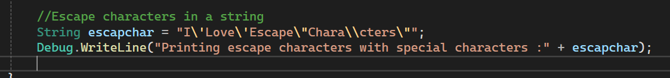

Output of the Above Program

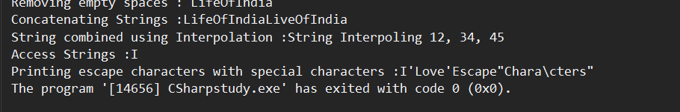

If..Else..Else If are same as Java.

Switch Case

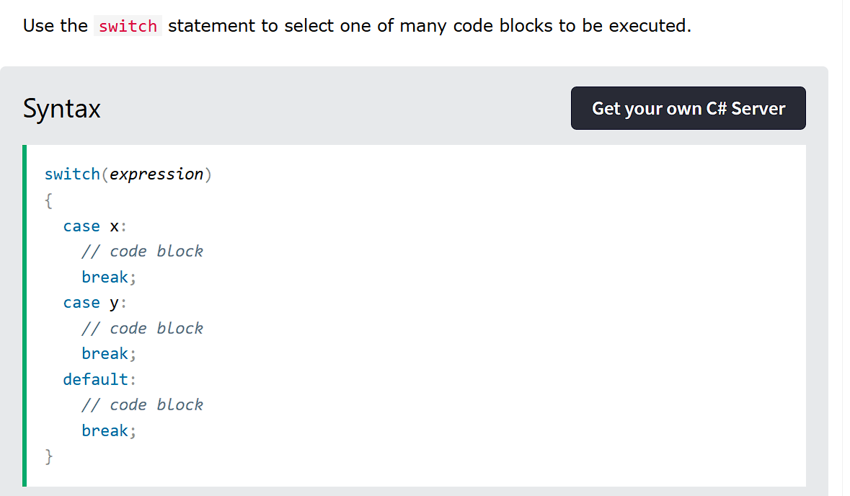

While and do While are same as Java.

For Loop is same as Java.

For Each loop:

Instead of colon, “In” keyword is used. Find below the syntax

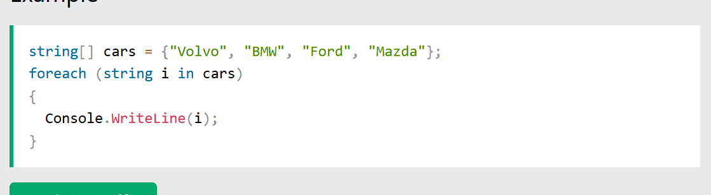

Continue Keyword Example:

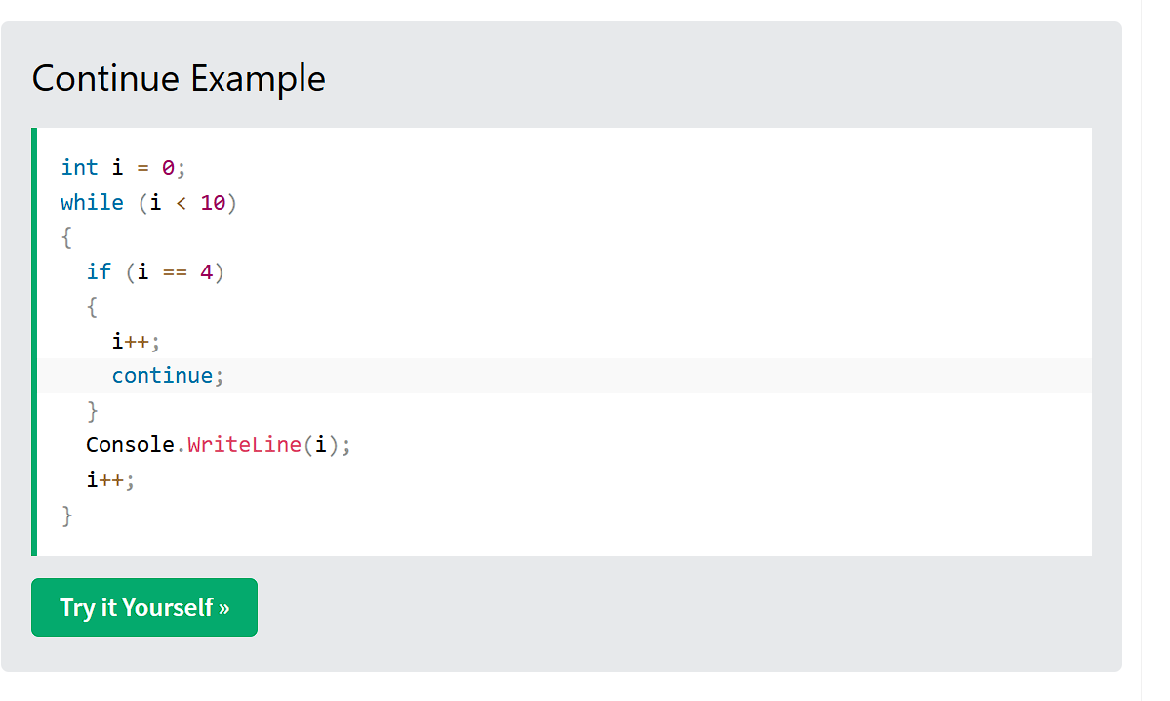

Output of the above Program

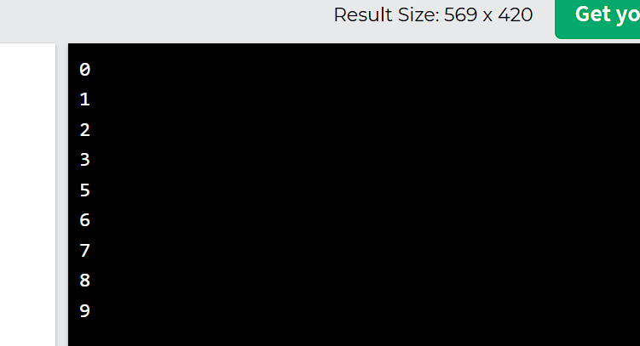

Arrays are same as in Java.